Create IAM user

Steps
- Create iam group/user with ec2 full access
- Create access key and secret

- Create iam group/user with ec2 full access

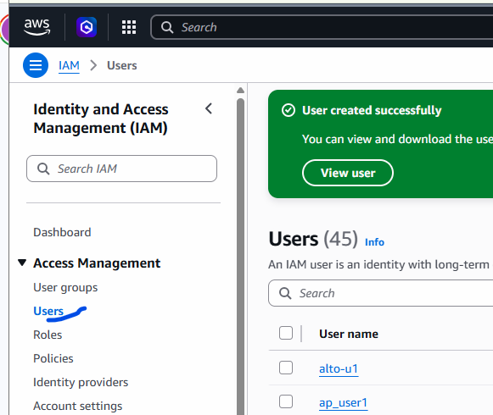
Click on user and then on the right side , click on “Create user”
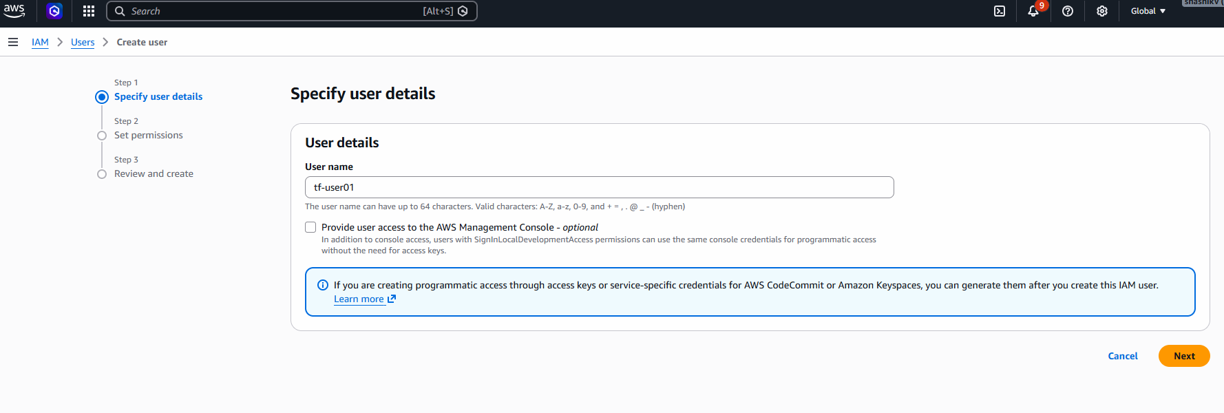
Click Next.
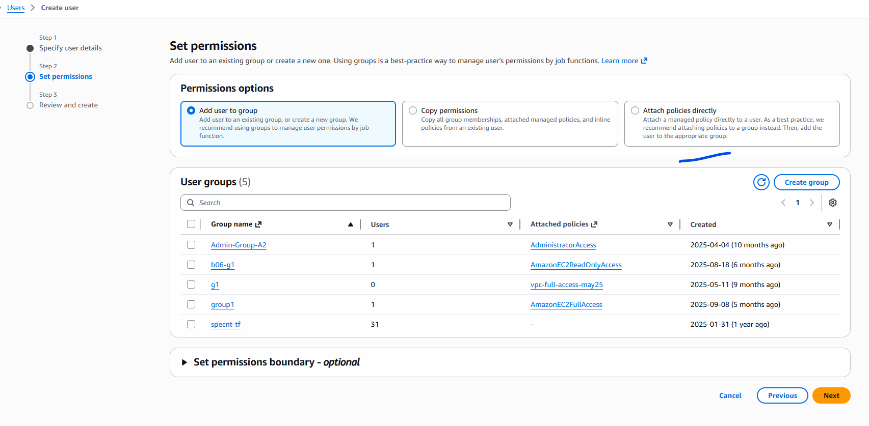
Click on “Attach policies directly”
And in the permission search for “ec2full”
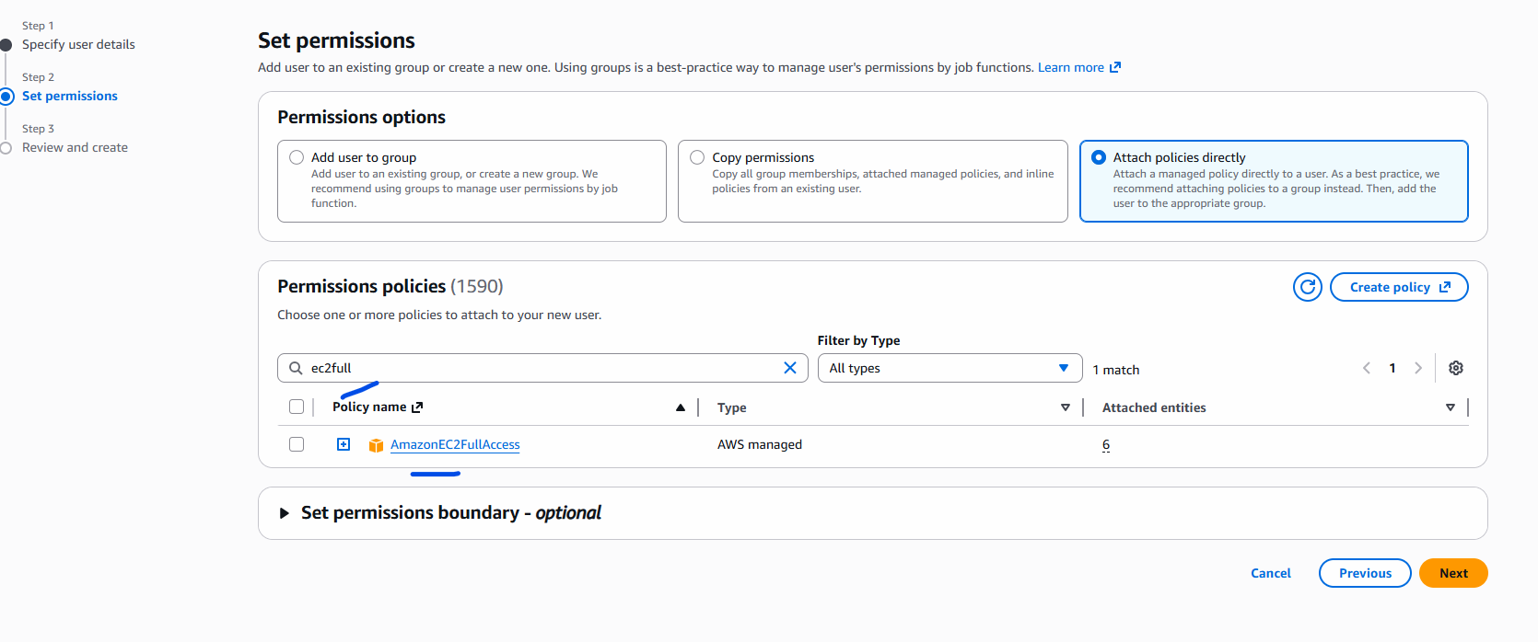
Put a tick mark and click on next.

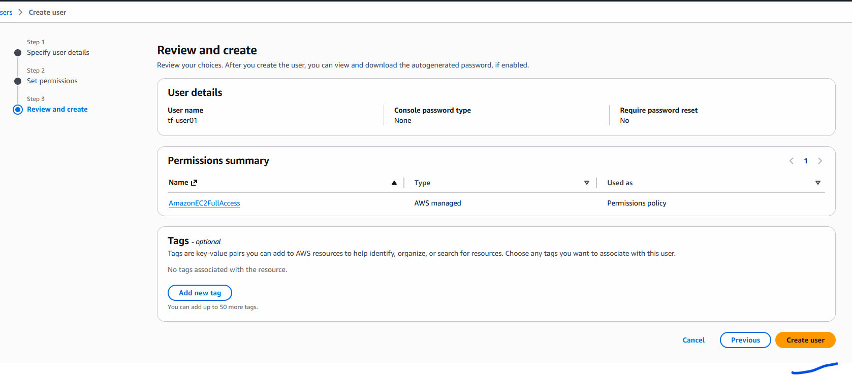

Click on Create user.

